CRCT Practice
Daily Warm-Ups

New South

SS8H7 The student will evaluate key political, social, and economic changes that occurred in Georgia between 1877 and 1918.
a Evaluate the impact the Bourbon Triumvirate, Henry Grade, International Cotton States Exposition, Tom Watson, and the Populists, Rebecca Latimer Felton, the 1906 Atlanta Riot , the Leo Frank Case, and the county unit system had on Georgia during this period.

Bourbon Triumvirate

_____280) Which statement BEST explains why the term Bourbon Triumvirate was most appropriate for Joseph Brown, Alfred Colquitt, and John Gordon?
a. They shared a strong belief in white supremacy.
b. They ruled the state consecutively for a period of over 30 years.
c. They were political rulers drawn together by power and political goals.
d. They were known for excessive business practices and high profit motives.

_____281) Joseph Brown, a member of the Bourbon Triumvirate, did not support
a. increasing the number of industries in the South.
b. creating stronger economic ties to the North.
c. white supremacy.
d. states’ rights.

_____282) The Bourbon Triumvirate believed in
a. lower taxes.
b. stronger economic ties with the industrial north in order to expand Georgia’s economy & white
supremacy.
c. economic assistance for the poor.
d. expansion of educational opportunities.

_____283) Which description BEST explains how the Bourbon Triumvirate might have described the Redemption period?
- A time for black and white southerners to come together and work in harmony to rebuild the state’s economic, social and political systems.
- A blending of the new and old, keeping old southern traditions while building new traditions around industries to rival the North.
- A New South Progressive era when farms had to be replaced by business and industry in order for the South to prosper.
- A time for social, economic, and political reforms to ease the suffering caused by the war.

Henry Grady

_____284) As the leader of the New South movement, what was Henry Grady supporting?
a. blacks leaving the South to work in the North
b. southerners growing more cotton for export
c. northern investment in southern industry
d. southern investment in northern factories

_____285) Which Georgians and his achievement are matched correctly?
a. Tom Watson – civil rights leaders
b. Hoke Smith – inventor of the steam engine
c. Henry Grady – editor of the Atlanta Constitution
d. Robert Toombs – mayor of Atlanta after the Civil War

_____286) The New South, envisioned by Henry W. Grady, would
a. provide separate facilities for different races.
b. maintain its southern heritage.
c. rival the North economically.
d. promote tourism.

_____287) What Georgia leader coined the phrase “New South?”
- Alfred H. Colquitt
- Rebecca Latimer Felton
- John B. Gordon
- Henry W. Grady

International Cotton States Exposition/Cotton States and International Exposition

_____288) The main purpose of the International Cotton Exposition that was held in Atlanta was to
a. showcase the industries of the New South.
b. get ideas from foreign countries.
c. showcase the cotton gin.
d. bring visitors to Atlanta.

_____289) The International Cotton Exposition was held in
- Athens.
- Atlanta.
- Augusta.
- Savannah

Tom Watson and The Populists

_____290) What Georgia Populist leader called on black and white farmers to unite in an effort to gain fair treatment from the state and national governments?
a. Joseph E. Brown
b. Henry Grady
c. Hoke Smith
d. Tom Watson

_____291) The Populist party in Georgia was the party of the
- Wealthy.
- Abolitionists.
- Small farmers.
- Federal bureaucrats.

_____292) What group was supported by Tom Watson, a Georgia populist?
- Farmers.
- Mill workers.
- Miners.
- Railroad workers.

_____293) What was Tom Watson’s greatest accomplishment?
- A voting bill for women
- The Rural Free Delivery Bill
- A bill to provide meat inspection
- A bill to increase the minimum wage

Rebecca Latimer Felton

_____294) When Rebecca Latimer Felton wrote for the Atlanta Journal, she focused on the need for reforms in
- Voting laws.
- Race relations.
- The prison system.
- Working conditions.

_____295) Rebecca Latimer Felton did NOT support the
- Educational reform movement.
- Temperance movement.
- Suffrage movement.
- Convict lease system.

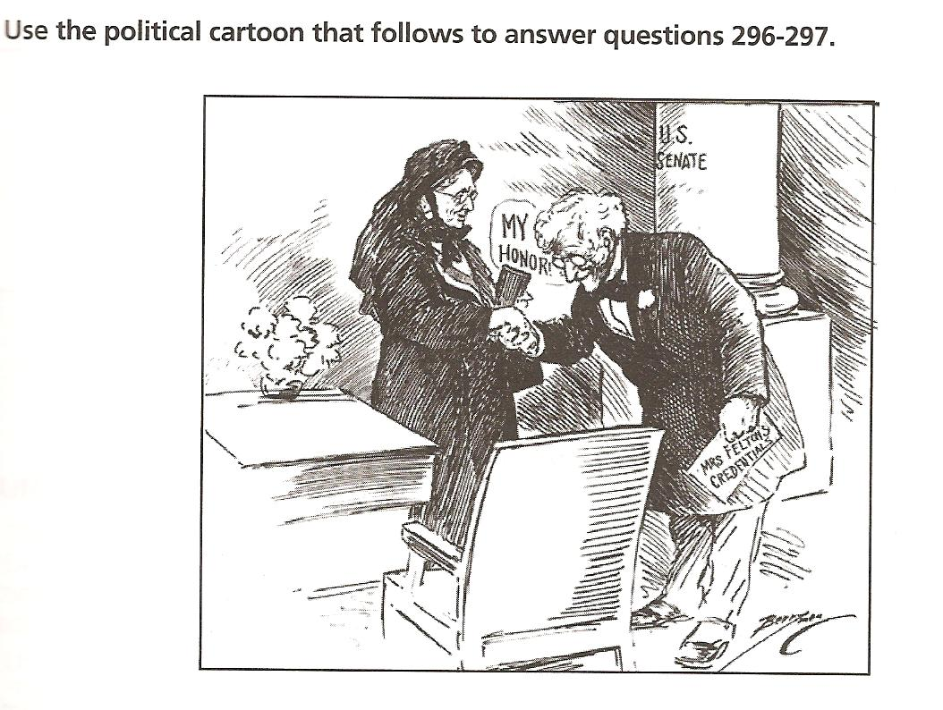

_____296) What is the subject of the political cartoon?
- Rosa Park’s meeting with a U. S. senator.
- Rebecca Latimer Felton serving as a U. S. senator.
- Carrie Nation’s testimony before the U. S. Congress.
- A recognition ceremony for widows of World War I

_____297) Which clue helps to identify the content of the political cartoon?
- The clothing that the two people are wearing
- The name of one of the people pictured
- The desk and table in the cartoon
- The gentlemen’s greeting

Miscellaneous

_____1) How did the Bourbon Triumvirate affect 19th century Georgia?
- They promoted industrial and commercial development in Georgia.
- They created laws that protected the rights of sharecroppers.
- They reformed state politics so women could run for office.
- They expanded government programs in order to help the poor.

_____2) The Leo Frank Case was important for Georgia because it showed how
- Widespread prejudice against Jews could prevent a fair trial.
- Rich defendants could easily bribe judges to avoid punishment.
- Witnesses would be ignored simply because they were black.
- Murder victims were often ignored if they were of a lower class.

_____3) Following the decision made in Plessy v. Ferguson in 1896, many states in the south, including Georgia, began creating laws that intentionally segregated blacks from whites in most parts of society. In Georgia, specific laws were passed mandating that blacks and whites have different restaurants and baseball fields. Why were these laws allowed after the 14th amendment had been passed and ratified?
- According to Plessy v. Ferguson, as long as the facilities were “equal” it was okay to separate them.
- The Supreme Court said that Jim Crow laws did not fall under the Constitution.
- No one was fighting against these laws since the majority of people wanted them.
- Since this was only happening in southern states like Georgia, many blacks simply moved north to avoid the laws.

_____4) During his first extended stay in Georgia, W. E. B. DuBois had which impact on race relations?
- He used his status as the “Great Accommodator” to build relationships with white leaders and get invited to the White House.
- He conducted several important research projects on blacks and crime and help to found the NAACP.
- His barbership and investment in real estate helped to unify blacks and whites.
- He realized through his research that a peaceful, non-threatening approach was the way to unify blacks and whites.

